Student Project Sheet – Template
Oct 13, 2026
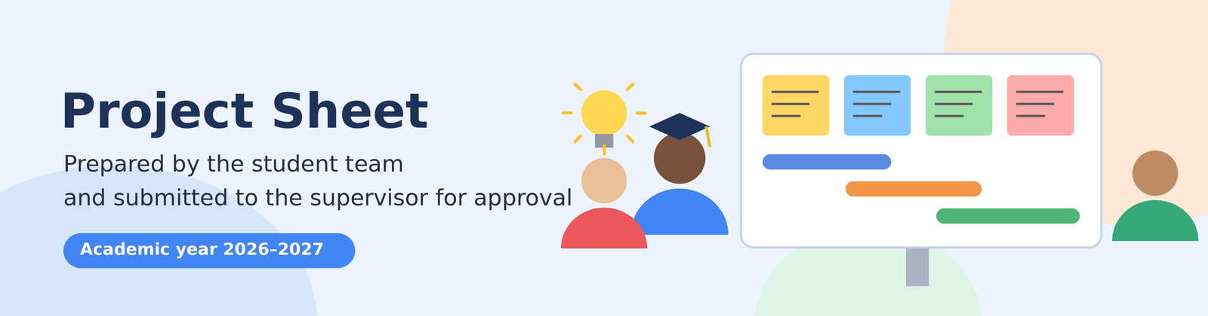
This sheet is prepared by the student team, then submitted to the supervisor for approval before the project starts. Replace the fields in square brackets with your own information.


1. General information
Item | To complete
Project title | IQO Bot: Adaptive Multimodal Laboratory Assistant — Hardware Prototype Feasibility Study
Institution / Faculty | Faculty of Sciences & Technology
Department / Programme | Department of Computer Science & Electrical Engineering / Software Engineering & Applied Intelligent Systems Module
Level | Engineering Degree / Academic Module
Project type | Supervised project / hardware prototype
Academic year | 2026–2027
Supervisor | Pr. Athmani.S
Co-supervisor (if any) | None
Host organisation (if any) | Faculty of Sciences & Technology / Department of Computer Science & Electrical Engineering
Start date / end date | Week 1 – Week 12 (12 weeks / 1 academic semester)
Team members
Full name | Student ID | Email | Role in the project
Berbache Ayoub | [ 35527307] | [a.berbachehns-re2sd.dz ] | Ai models and brain logic  Parts printing and assembly
Filalli Yacine Siradj Eddin | [34288907 ] | [ys.fillali@hns-re2sd.dz ] | Server and robot routing and security system  Robot assembly
Malem Mohamed Mahdi | [35146020 ] | [mm.malem@hns-re2sd.dz ] | Dashboar (UI\UX)  SqlLite DB configuration and datasets gathering


2. Background and problem statement
Background:
In university practical laboratory sessions, a single instructor typically supervises 30 to 40 students across 15 to 20 workbench stations. Students frequently spend 10 to 15 minutes waiting for basic troubleshooting assistance (e.g. diagnosing loose wires, misidentified IC pins, or incorrect oscilloscope probe grounding). More critically, novice students regularly cause hardware damage—such as breadboard power rail short circuits, blown multimeter fuses, and burned integrated circuits—costing departments substantial funds each semester. Commercial laboratory automation units cost upwards of $1,000–$2,000, making them impossible to deploy for university student benches. There is a pressing need for a low-cost, self-contained physical assistant prototype that can detect wiring anomalies, interact naturally via voice and visual LCD feedback, and operate safely on the student workbench with zero recurring operational cost.
Problem statement:
How can an affordable, self-contained physical benchtop assistant be constructed to prevent laboratory hazards (such as short circuits) and provide real-time voice and visual guidance during practical sessions without incurring cloud service costs?
Target users / beneficiaries:
- Primary: University project examination jury, module professor (Pr. Athmani.S), and project team members.
- Secondary: Undergraduate engineering students and laboratory teaching assistants participating in prototype evaluation trials.


3. Objectives
Main objective:
Construct and validate a standalone physical prototype integrating ESP32-S3, I2S audio I/O, SPI LCD display, battery/USB-C power, and multi-sensor suite, interfaced with a zero-cost local PC AI reasoning core.
Specific objectives:
- Achieve low-latency sensor loop polling latency under 50 ms and instant short-circuit current detection with an alarm/cut-off in under 20 ms.
- Provide real-time local speech transcription and an AI response start time under 500 ms using open-source models (Ollama LLaMA-3 8B / Qwen-2.5, Whisper.cpp, Piper TTS) running locally at $0 cost.
- Deliver animated visual cues, facial status icons, and schematics on a 2.4-inch SPI color LCD display at a refresh rate ≥ 25 FPS.
- Ensure autonomous bench operation with continuous rechargeable battery runtime ≥ 3 hours via an onboard 18650 Li-ion battery and TP4056 USB Type-C module.
- Cap total prototype expenditure under 15,000 DZD with 0 DZD cloud subscription or API fees.
Expected results:
A working proof-of-concept hardware prototype node (ESP32-S3, sensors, audiovisual peripherals, power system, 3D printed desktop mount), local AI host pipeline, test reports, and an academic defense presentation.


4. Methodology and resources
Approach:
Iterative engineering lifecycle across six distinct 12-week phases, combining embedded FreeRTOS/C++ driver development on the microcontroller with a local Python/FastAPI backend hosting quantized open-source AI models.
Main steps:
- Phase 1: Requirements, Pinout Design & Parts Procurement
- Phase 2: Hardware Breadboarding (ESP32, Audio, LCD & Sensors)
- Phase 3: Power Management (Battery, Type-C) & Firmware Drivers
- Phase 4: Local AI Pipeline (Ollama/PyTorch on PC) & Wi-Fi Link
- Phase 5: System Integration, Enclosure Assembly & Pilot Testing
- Phase 6: Final Demo, Evaluation & Academic Report Defense
Required resources
Type | Details | Available?
Software / tools | ESP-IDF / Arduino C++, FreeRTOS, Python 3.10, FastAPI, Ollama (LLaMA-3 8B / Qwen-2.5), Whisper.cpp, Piper TTS, PyTorch, ChromaDB | Yes
Equipment | ESP32-S3 DevKit-C (8MB PSRAM), INMP441 I2S Mic, MAX98357A I2S Amp + 3W Speaker, 2.4" SPI TFT LCD, INA219, HC-SR04, DHT22, LDR, 18650 Li-ion battery, TP4056 Type-C board, MT3608 boost converter, student PC/laptop | Yes
Data / field access | Access to university electronics breadboards, workbench stations, and practical laboratory trial sessions | Yes
Estimated budget | 13,200 DZD (Hardware BOM) + 1,500 DZD (testing spares contingency) = 14,700 DZD (~$108.50 USD); $0 AI/software cost | Yes


5. Schedule and deliverables
Phase | Start | End | Deliverable | Owner
Literature review & State of the art | Week 1 | Week 2 | State-of-the-art summary & component procurement | Malem Mahdi
Needs analysis & Requirements | Week 1 | Week 2 | Requirements specification & pinout matrix | Malem Mahdi
Design | Week 3 | Week 4 | Hardware circuit design & audiovisual loopback verification | Berbache Ayoub
Implementation | Week 5 | Week 10 | Working hardware prototype, local AI integration & 3D enclosure | Berbache / Filalli / Malem
Testing and validation | Week 11 | Week 12 | Test report & lab trial benchmark validation | Whole team
Writing | Week 11 | Week 12 | Final project report | Whole team
Defence | Week 12 | Week 12 | Oral presentation & physical prototype demo | Whole team
Progress meetings with the supervisor: Scheduled bi-weekly progress review and guidance sessions with Pr. Athmani.S.


6. Risks and mitigation
Identified risk | Likelihood | Planned response
Component procurement delay from local electronics shops | Medium (Prob: 2, Imp: 2) | Source components early in Week 1; maintain interchangeable alternative sensor models (e.g. DHT11 vs DHT22; INA219 vs ACS712)
Student PC hardware struggle with local LLM inference speed | Medium (Prob: 2, Imp: 2) | Use aggressively quantized 4-bit small language models (LLaMA-3.2 1B / 3B or Qwen-2.5 1.5B/3B) that generate 30+ tok/s even on standard laptop CPUs
Battery power fluctuation causing ESP32 brownout during Wi-Fi transmission | Medium (Prob: 2, Imp: 2) | Include a 470µF decoupling electrolytic capacitor across the 5V power rails; use quality 2A boost converter


7. Approval
Role | Name | Date | Signature
Project leader (student) | Berbache Ayoub | 14/10/2026
Supervisor | Pr. Athmani.S | ___ / ___ / 2026
Programme head | Faculty of Sciences & Technology | ___ / ___ / 2026
Supervisor's decision: ☐ Approved ☐ Approved with changes ☐ Rejected
Comments: ……………………………………………

